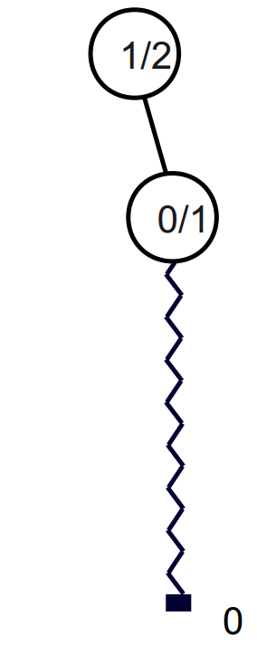
Root
Leaf
Random
simulation
Number of simulations
Number of
favorable issues

